**Introduction**

Corneal opacification is the 5th leading cause of bilateral blindness worldwide, with the majority of cases due to infection.1–3 The burden of infectious keratitis (or “corneal ulceration”) is highest in the developing world where resources to address it are most scarce.1 This has prompted a recent proposal in the Bulletin of the World Health Organization to assign neglected tropical disease status to corneal ulceration in an attempt to increase resource allocation to this significant but underrecognized condition.4

Infectious keratitis is characterized by bacterial, fungal, viral, or parasitic invasion of the corneal stroma. These classes of pathogens are quite different, causing differing courses of clinical disease and requiring distinct therapeutic regimens. For example, antibiotics are ineffective against fungi, antifungals are ineffective against bacteria, and steroids likely have a role in the treatment of bacterial keratitis but can be harmful in fungal keratitis.5,6 Earlier treatment for the correct pathogen improves visual outcomes. Thus, prompt identification of the etiology of infectious keratitis is important to guide antimicrobial therapy, particularly the differentiation between bacterial and fungal keratitis.5,7

Cultures of corneal scrapings are the current gold standard method for determining the infectious etiology of corneal ulcers but are negative in 40-60% of cases.8,9 Even when cultures are positive, the results are not available for several days or longer, depending on the pathogen. In the absence of culture data, treatment decisions must be made empirically based on clinical interpretation of the history and appearance of the ulcer. Several distinguishing features in the clinical appearance of fungal keratitis have been described, including “feathery” or “hyphate” lines at the borders of the corneal infiltrate, a dry or rough texture, an elevated plaque-like configuration, and satellite lesions, among others.10,11 Nonetheless, clinical differentiation between bacterial and fungal keratitis remains highly unreliable. Even expert cornea clinicians are only able to correctly distinguish bacterial from fungal keratitis 66-73% of the time based on history and examination.10,12 As a result, there is a clinically significant gap in our ability to rapidly initiate directed antimicrobial therapy for infectious keratitis. This represents an opportunity to improve the clinical differentiation of bacterial and fungal keratitis using artificial intelligence for image-based diagnosis, or “computer vision.”

Developing a DL system for image-based diagnosis requires a large dataset of clinical images and the corresponding “ground truth” (or gold standard) diagnosis. Over the past several decades, my mentors at the Francis I Proctor Foundation and the Aravind Eye Care System have performed several NIH-supported clinical trials to guide the management of infectious keratitis, including the Steroids for Corneal Ulcers Trial (SCUT), Mycotic Ulcer Treatment Trials I & II (MUTT), Cross-Linking-Assisted Infection Reduction I & II (CLAIR), and Mycotic Antimicrobial Localized Injection (MALIN).5,13–15 Each corneal ulcer in these trials was proven to be bacterial or fungal based on smear or culture results, and for each subject photographs were taken of the ulcer at initial presentation. This has allowed us to develop a database of 1,204 cases of culture-positive bacterial or fungal keratitis, each with standardized clinical photographs. Herein I describe the use of this database to train and evaluate a convolutional neural network for automated differentiation of bacterial from fungal keratitis based only on corneal imaging.

**Methods**

To perform this binary classification objective, I elected to use a convolutional neural network (CNN) because of their demonstrated history of outperforming other models for computer vision applications. I constructed a CNN based on the LeNet architecture described by LeCun et al in 1998.16 This architecture consists of the following layers:

1. Preprocessing

* Resize input image to 256x256 pixels
* Rescale pixel values to range from 0 to 1 (by dividing pixel value by 256)

1. A convolutional layer with pad = 2, stride = 1, and 20 filters
2. A rectified linear unit (ReLU) activation layer
3. A max pooling layer with 2x2 filters and a stride of 2
4. A second convolutional layer with pad = 2, stride = 1, and 50 filters
5. A second ReLU activation layer
6. A second max pooling layer with 2x2 filters and a stride of 2
7. A single densely connected layer with a sigmoid activation function

As a result of the sigmoid output function, the model produces an estimated probability that the input image represents a fungal corneal ulcer (and, by extension, the complement of the probability that the image depicts a bacterial corneal ulcer because in this dataset bacterial and fungal infections are mutually exclusive and an exhaustive list of the possible causes of infection).

Model output = P(Fungal)

1 – Model output = P(Bacterial)

The image set consisted of 1204 images of culture-proven bacterial and fungal corneal ulcers. These were randomly split into a training set (80%) and validation set (20%). 10 images obtained at a different center in India were held out as a test set to assess the generalization error of the model.

The model was trained using TensorFlow in Python 3 using the Adam optimization algorithm, mini-batch size of 64, and 50 epochs. The resulting weights (a total of 204,801 trained parameters) were stored for future use in the hand-built model.

I then constructed each of the layers of the forward pass of the LeNet model from scratch using Python and pulled the weights from the previously trained TensorFlow model to be applied to this hand-built model. These helper functions included:

1. A zero-padding function:

* Input: A 3D matrix of any size (height x width x # channels)
* Arguments: amount of zero-padding desired
* Output: A zero-padded matrix

1. A convolution function:

* Input: A 3D matrix of any size
* Arguments: A 4D matrix of weights, desired stride, desired padding, and the number of filters to be applied
* Output: A convolved 3D matrix

1. A max pooling function:

* Input: A 3D matrix of any size
* Arguments: The desired filter size and stride length
* Output: A pooled matrix

1. A ReLu function:

* Input: A numpy array of any size
* Output: A numpy array of the same size as the input

1. And a sigmoid function:

* Input: A scalar
* Output: A scalar ranging from 0 to 1

The resulting model is available as LeNet_model_script.py, and the Jupyter Notebook containing the source code for all model development steps is available as ConvNet.html. The final model takes an image of any size as input and returns a prediction for the cause of the corneal ulcer (either bacterial or fungal) as well as the estimated probability of this prediction. Also included in this submission are the 10 images comprising the hold-out testing set (5 bacterial and 5 fungal images) and a Python pickle object containing a dictionary of all weights employed by the model.

**Results**

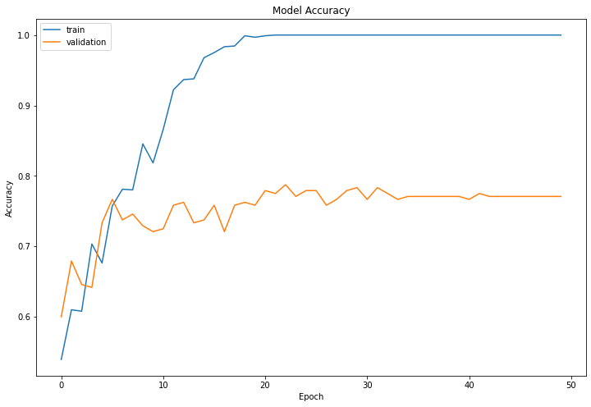

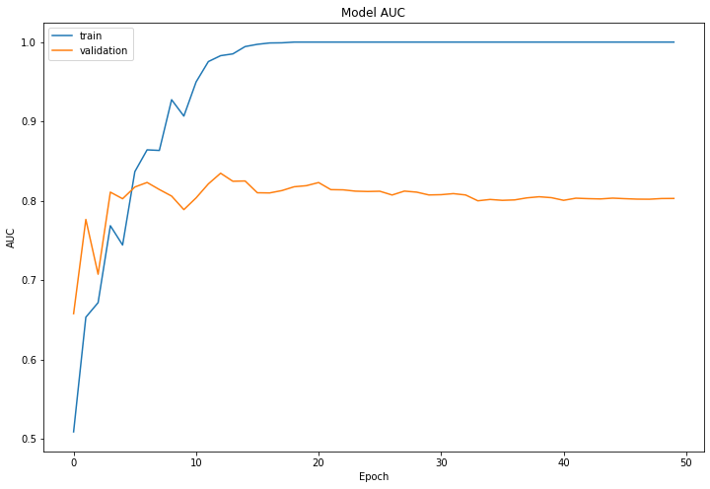

As can be seen from the plots above, the model reached peak accuracy and AUROC after approximately 20 epochs of training. The model achieved perfect accuracy and AUROC on the training set, and an AUROC of 0.8 on the validation set, indicating a moderate amount of overfitting. However, the generalizability of the model remained good based on examination of the results on the hold-out test set, where the model was correct in 9 out of 10 cases. However, this is a small sample size, and the true generalizability will require additional investigation.

**Discussion**

Image-based diagnosis has become integral to the practice of modern ophthalmology, and machine learning is rapidly changing this landscape for many ophthalmic diseases. The project described herein develops and evaluates a novel convolutional neural network, which may improve the diagnostic evaluation of infectious keratitis. The model performed better than expected for this binary classification task, particularly considering that the model architecture is relatively simple compared to newer CNNs such as Resnet, VGG, etc. In fact, its performance is similar or superior to human performance in this same task. This demonstrates there is potential for a computer vision application to this classification problem. Moving forward I intend to apply a transfer learning approach using a more complex, modern CNN architecture pre-trained on ImageNet to attempt to further improve model accuracy. I also intend to collect a larger external testing set to better evaluate the generalizability of these models, and later develop a multi-class prediction model that can predict any type of corneal infection.

**References**

1. Flaxman SR, Bourne RRA, Resnikoff S, et al. Global causes of blindness and distance vision impairment 1990–2020: a systematic review and meta-analysis. *Lancet Glob Heal*. 2017;5(12):e1221-e1234. doi:10.1016/S2214-109X(17)30393-5

2. Whitcher JP, Srinivasan M, Upadhyay MP. Corneal blindness : a global perspective. *Bull World Heal Organ*. 2001;79:214-221.

3. Pascolini D, Mariotti SP. Global estimates of visual impairment: 2010. *Br J Ophthalmol*. 2012;96(5):614-618. doi:10.1136/bjophthalmol-2011-300539

4. Ung L, Acharya NR, Agarwal T, et al. Infectious corneal ulceration : a proposal for neglected tropical disease status. 2019;(March):854-856.

5. Srinivasan M, Mascarenhas J, Rajaraman R, et al. The steroids for corneal ulcers trial (SCUT): Secondary 12-month clinical outcomes of a randomized controlled trial. *Am J Ophthalmol*. 2014;157(2). doi:10.1016/j.ajo.2013.09.025

6. Pineda R, Dohlman CH. The role of steroids in the management of Acanthamoeba keratitis, fungal keratitis, and epidemic keratoconjunctivitis. *Int Ophthalmol Clin*. 1994;34(3):19-31. doi:10.1097/00004397-199403430-00005

7. Prajna NV, Krishnan T, Mascarenhas J, et al. The Mycotic Ulcer Treatment Trial. *JAMA Ophthalmol*. 2013;131(4):422. doi:10.1001/jamaophthalmol.2013.1497

8. McLeod SD, Kumar A, Cevallos V, Srinivasan M, Whitcher JP. Reliability of transport medium in the laboratory evaluation of corneal ulcers. *Am J Ophthalmol*. 2005;140(6). doi:10.1016/j.ajo.2005.06.042

9. Varaprasathan G, Miller K, Lietman T, et al. Trends in the Etiology of Infectious Corneal Ulcers at the F. I. Proctor Foundation. *Cornea*. 2004;23(4):360-364. doi:10.1097/00003226-200405000-00009

10. Dalmon C, Porco TC, Lietman TM, et al. The clinical differentiation of bacterial and fungal keratitis: a photographic survey. *Invest Ophthalmol Vis Sci*. 2012;53(4):1787-1791. doi:10.1167/iovs.11-8478

11. Rosa RH, Miller D, Alfonso EC. *The Changing Spectrum of Fungal Keratitis in South Florida*. Vol 101.; 1994. doi:10.1016/S0161-6420(94)31225-5

12. Dahlgren MA, Lingappan A, Wilhelmus KR. The clinical diagnosis of microbial keratitis. *Am J Ophthalmol*. 2007;143(6):940-944. doi:10.1016/j.ajo.2007.02.030

13. Prajna NV, Krishnan T, Rajaraman R, et al. Effect of Oral Voriconazole on Fungal Keratitis in the Mycotic Ulcer Treatment Trial II (MUTT II): A Randomized Clinical Trial. *JAMA Ophthalmol*. 2016;134(12):1365-1372. doi:10.1001/jamaophthalmol.2016.4096

14. Narayana S, Krishnan T, Ramakrishnan S, et al. Mycotic Antimicrobial Localized Injection A Randomized Clinical Trial Evaluating Intrastromal Injection of Voriconazole. *Ophthalmology*. 2019;126(8):1084-1089. doi:10.1016/j.ophtha.2019.03.020

15. Prajna NV, Radhakrishnan N, Lalitha P, et al. Cross-Linking–Assisted Infection Reduction: A Randomized Clinical Trial Evaluating the Effect of Adjuvant Cross-Linking on Outcomes in Fungal Keratitis. *Ophthalmology*. February 2019. doi:10.1016/j.ophtha.2019.08.029

16. LeCun Y, Bottou L, Bengio Y, Haffner P. Gradient-based learning applied to document recognition. *Proc IEEE*. 1998;86(11):2278-2323. doi:10.1109/5.726791